# Do while loop in C++

Practice 01:

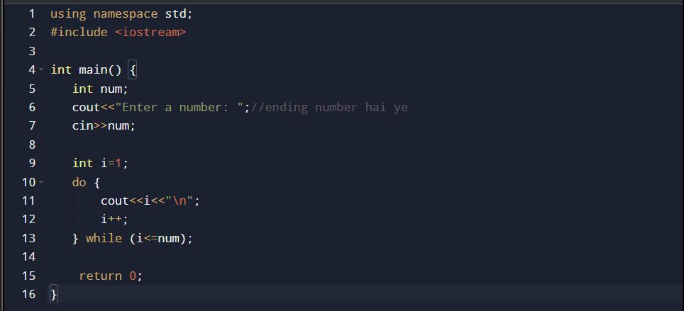

Practice 02;

Practice 03:

Practice 04:

Practice 05:

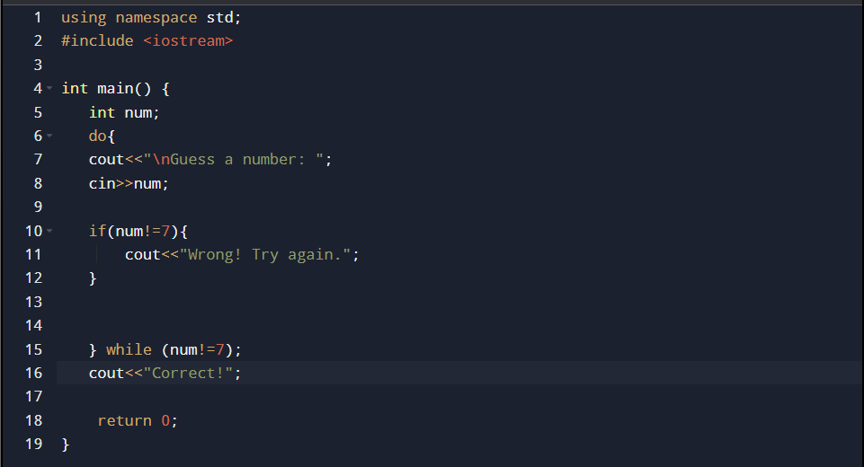

practice 06:

Practice 07:

Practice 08:

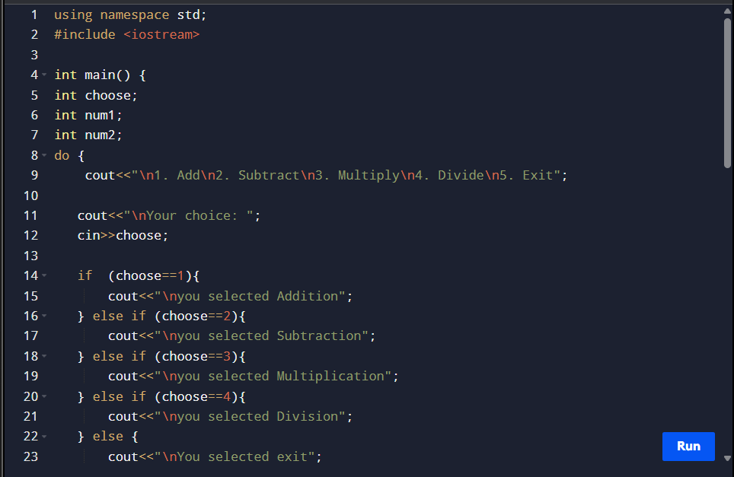

Practice 09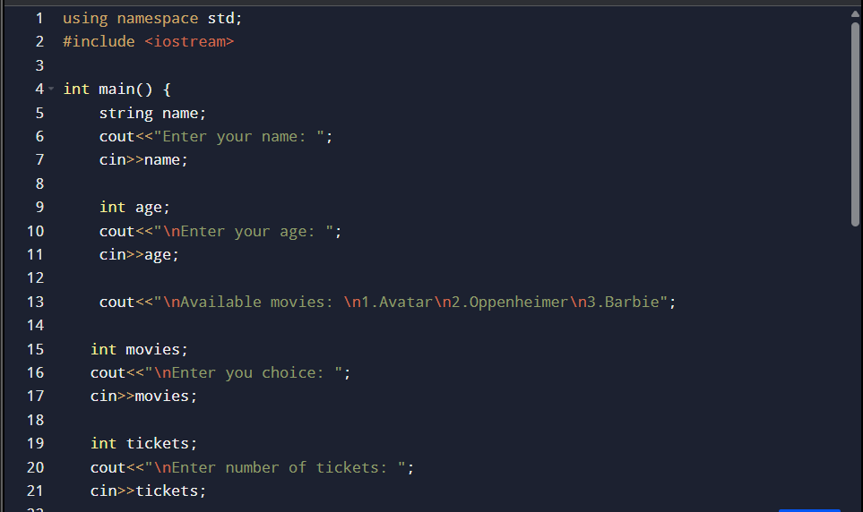

Practice 10:

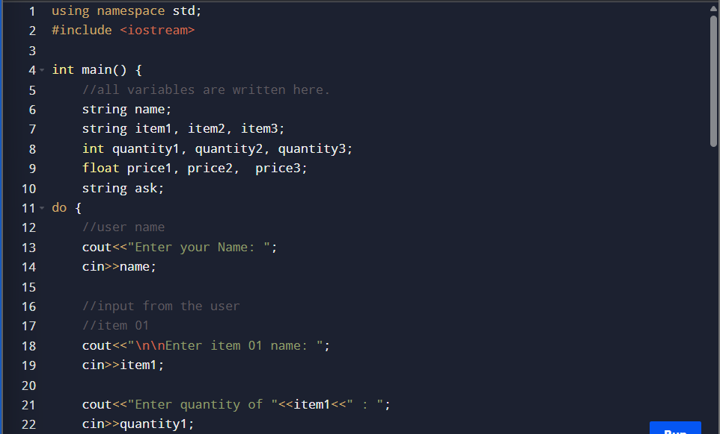

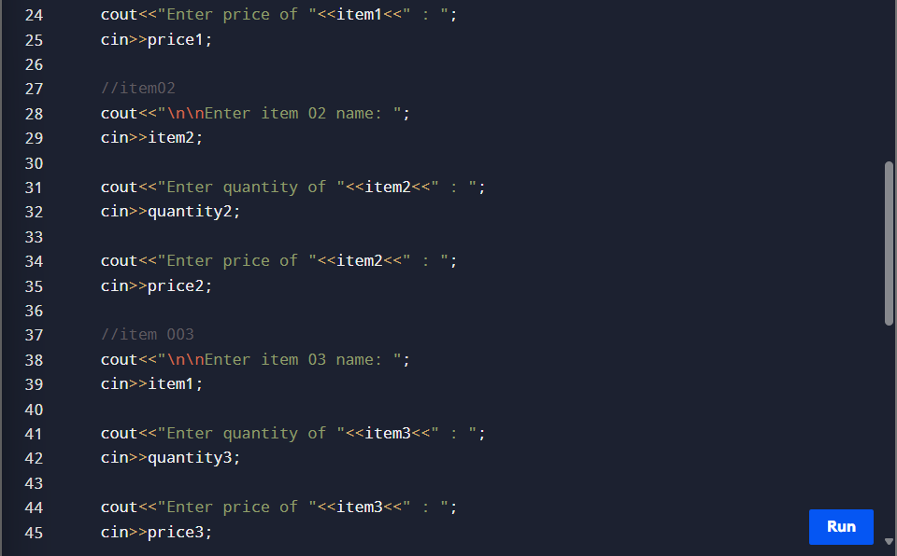

Practice 11;



